

Project File
Web Programming using
Python and JavaScript

Submitted By: Submitted To:
Name: Tanmay Dixit Name: Dr. Mansi Kajal
Course: B-Tech CSE Core
Year: 2nd Year, 4th Semester
Roll No: 2401010120

EXPERIMENT-1
Aim: Personal portfolio using html and css
HTML CODE:
</section>
<section id="about">
<h2>About Me</h2>
<p>
I am a B.Tech CSE (Core) student at K.R. Mangalam University with interests in
Software Development, Data Analytics, and Artificial Intelligence.
I enjoy building applications and working on real-world problem-solving projects.
</p>
</section>
<section id="skills">
<h2>Skills</h2>
<div class="card-container">
<div class="card">C++</div>
<div class="card">Python</div>
<div class="card">Java</div>
<div class="card">AI / ML</div>
<div class="card">Gradio</div>
<div class="card">Google Colab</div>
</div>
</section>
<section id="projects">
<h2>Projects</h2>
<div class="project-card">
<h3>Life Line Network</h3>
<p>
Emergency medical service platform connecting patients, ambulance drivers,
and hospitals with real-time ambulance tracking using Google Maps API.
</p>
</div>
<div class="project-card">
<h3>Dermatobot</h3>
<p>
AI-based skin disease detection system capable of identifying 50+ skin diseases
from images with a real-time interactive UI.
</p>
</div>
</section>
<section id="contact">
<h2>Contact Information</h2>
<p>Email: tanmay0659@gmail.com</p>
<p>Phone: +91 8851240659</p>
<form>
<input type="text" placeholder="Your Name" required>
<input type="email" placeholder="Your Email" required>
<textarea placeholder="Your Message" required></textarea>
<button type="submit">Submit</button>
</form>
</section>
<footer>
<p>© 2026 Tanmay Dixit</p>
</footer>
</body>
</html>
CSS CODE:
* {
box-sizing: border-box;
}
body {
margin: 0;

font-family: 'Poppins', sans-serif;
background-color: #f8fafc;
color: #1f2937;
}
header {
background: linear-gradient(135deg, #1e293b, #0f172a);
color: white;
padding: 50px 20px;
text-align: center;
}
header h1 {
font-size: 40px;
margin-bottom: 10px;
}
header p {
font-size: 16px;
opacity: 0.9;
}
nav {
margin-top: 15px;
}
nav a {
color: #e5e7eb;
margin: 0 12px;
text-decoration: none;
font-weight: 500;
}
nav a:hover {
color: #38bdf8;
}
section {
padding: 60px 20px;
text-align: center;}

section h2 {
font-size: 28px;
margin-bottom: 20px;
color: #0f172a;
}
.static-btn {
padding: 12px 25px;
border-radius: 25px;
border: none;
background-color: #0ea5e9;
color: white;
cursor: pointer;
font-size: 14px;
}
.static-btn:hover {
background-color: #0284c7;
}
#about p {
max-width: 700px;
margin: auto;
line-height: 1.6;
}
.card-container {
display: flex;
flex-wrap: wrap;
justify-content: center;
gap: 15px;
}
.card {
background-color: white;
padding: 15px 25px;
border-radius: 25px;
box-shadow: 0 5px 15px rgba(0,0,0,0.08);
font-weight: 500;
transition: transform 0.2s;
}
.card:hover {
transform: translateY(-5px);
}
.project-card {
background-color: white;
margin: 20px auto;
padding: 25px;
max-width: 650px;
border-radius: 12px;
box-shadow: 0 10px 20px rgba(0,0,0,0.08);
text-align: left;
}
.project-card h3 {
margin-top: 0;
color: #0ea5e9;
}
#contact p {
margin: 6px 0;
}
form {
max-width: 420px;
margin: 30px auto 0;
}
form input,
form textarea {
width: 100%;
padding: 12px;
margin: 8px 0;
border-radius: 8px;
border: 1px solid #cbd5f5;
}

form button {
width: 100%;
padding: 12px;
background-color: #0ea5e9;
color: white;
border: none;
border-radius: 8px;
cursor: pointer;
}

form button:hover {
background-color: #0284c7;
}

footer {
background-color: #0f172a;
color: white;
text-align: center;
padding: 15px;
margin-top: 40px;

EXPERIMENT-2
AIM:
Tasks
Task 1: Project Setup & Introduction
• Create a project folder named company_landing_page
• Inside the folder, create:
o index.html
o style.css
• Add header comments in HTML (project title, name, date)
• Create an introduction section with company name and tagline
Deliverable:
Project folder with HTML and CSS files linked correctly.
______________
Task 2: HTML Structure – Page Sections
• Create the following sections using semantic HTML:
o Header / Hero section
o About / Introduction
o Services
o Testimonials
o Contact Information
• Use tags such as:
o <header>, <section>, <footer>
Deliverable:
Well-structured HTML page with all required sections.
______________
Task 3: Styling with CSS
• Apply CSS styling for:
o Page layout and spacing
o Background colors and fonts
o Section alignment and borders
• Use:
o Class and ID selectors
o Box model properties (margin, padding)
Deliverable:
style.css file with consistent and professional styling.
______________
Task 4: Services Section Design
• Add at least 3 services offered by the fictitious company
• Include:
o Service name
o Short description
• Use cards, lists, or grid-style layouts
Deliverable:
Services section clearly displayed and styled.
______________
Task 5: Testimonials Section
• Add at least 2 customer testimonials including:
o Customer name
o Short feedback
• Style testimonials for readability and emphasis
Deliverable:
Neatly formatted testimonials section.
______________
Task 6 (Bonus): Contact Form
• Add a contact section with:
o Address / Email / Phone
o Simple contact form (Name, Email, Message)
• No backend required (UI only)
HTML:
<!DOCTYPE html>
<html lang="en">

<head>
<meta charset="UTF-8" />
<meta name="viewport" content="width=device-width, initial-scale=1.0" />
<title>BrightWave Solutions</title>

<!-- Linking CSS file -->
<link rel="stylesheet" href="style.css" />
</head>

<body>

<header class="hero">
<div class="hero-content">
<h1 id="company-name">BrightWave Solutions</h1>
<p class="tagline">We help businesses grow with smart digital solutions.</p>
<a href="#services" class="btn">Explore Services</a>
</div>
</header>

<section class="section about" id="about">
<h2>About Us</h2>
<p>
BrightWave Solutions is a creative and technology-driven company that delivers modern websites, branding, and business tools. Our mission is to make your online presence more powerful and professional.
</p>
</section>

<!-- ========== SERVICES SECTION ========== -->
<section class="section services" id="services">
<h2>Our Services</h2>

<div class="service-grid">

<div class="service-card">
<h3>Website Development</h3>
<p>Modern, responsive and fast websites designed for all devices.</p>
</div>

<div class="service-card">
<h3>UI/UX Design</h3>
<p>Clean, user-friendly designs that enhance customer experience.</p>
</div>

<div class="service-card">
<h3>Digital Marketing</h3>
<p>SEO + social media marketing to boost your brand and visibility.</p>
</div>

</div>
</section>

<!-- ========== TESTIMONIALS SECTION ========== -->
<section class="section testimonials" id="testimonials">
<h2>What Our Clients Say</h2>

<div class="testimonial-box">
<p class="feedback">
“BrightWave built our website in just 5 days. Amazing design and super responsive team!”
</p>
<h4>- Riya Sharma</h4>
</div>

<div class="testimonial-box">
<p class="feedback">
“Highly professional service. Our business sales increased after their marketing support.”
</p>
<h4>- Aman Verma</h4>
</div>

</section>

<!-- ========== CONTACT SECTION (BONUS) ========== -->
<section class="section contact" id="contact">
<h2>Contact Us</h2>

<div class="contact-container">
<!-- Contact Info -->
<div class="contact-info">
<h3>Get in Touch</h3>
<p><b>Address:</b> Sector 21, Gurugram, Haryana</p>
<p><b>Email:</b> support@brightwave.com</p>
<p><b>Phone:</b> +91 98765 43210</p>
</div>

<!-- Contact Form -->
<div class="contact-form">
<form>
<label for="name">Full Name</label>
<input type="text" id="name" placeholder="Enter your name" required />

<label for="email">Email</label>
<input type="email" id="email" placeholder="Enter your email" required />

<label for="message">Message</label>
<textarea id="message" rows="5" placeholder="Write your message..." required></textarea>

<button type="submit" class="btn">Send Message</button>
</form>
</div>
</div>
</section>

<!-- ========== FOOTER SECTION ========== -->
<footer class="footer">
<p>© 2026 BrightWave Solutions. All Rights Reserved.</p>
</footer>

</body>

</html>
CSS:

* {
margin: 0;
padding: 0;
box-sizing: border-box;
font-family: Arial, sans-serif;
}

body {
background-color: #f4f6f9;
color: #222;
line-height: 1.6;
}

.hero {
background: linear-gradient(to right, #0077ff, #00c6ff);
color: white;
height: 90vh;
display: flex;
justify-content: center;
align-items: center;
text-align: center;
padding: 20px;
}

.hero-content h1 {
font-size: 48px;
margin-bottom: 15px;
}

.tagline {
font-size: 18px;
margin-bottom: 25px;
}

.btn {
display: inline-block;
background: white;
color: #0077ff;
padding: 12px 25px;
text-decoration: none;
font-weight: bold;
border-radius: 8px;
transition: 0.3s;
}

.btn:hover {
background-color: #222;
color: white;
}

.section {
padding: 60px 10%;
text-align: center;
}

.section h2 {
font-size: 32px;
margin-bottom: 20px;
color: #0077ff;
}
.about p {
font-size: 16px;
max-width: 800px;
margin: auto;
}

.service-grid {
display: grid;
grid-template-columns: repeat(auto-fit, minmax(250px, 1fr));
gap: 20px;
margin-top: 30px;
}

.service-card {
background-color: white;
padding: 25px;
border-radius: 12px;
border: 2px solid #eee;
box-shadow: 0px 4px 10px rgba(0, 0, 0, 0.08);
transition: 0.3s;
}

.service-card:hover {
transform: translateY(-5px);
border-color: #0077ff;
}

.service-card h3 {
color: #222;
margin-bottom: 10px;
}
.testimonials {
background-color: #ffffff;
}

.testimonial-box {
background-color: #f4f6f9;
margin: 20px auto;
padding: 20px;
max-width: 700px;
border-left: 5px solid #0077ff;
border-radius: 10px;
}

.feedback {
font-style: italic;
margin-bottom: 10px;
}

.contact-container {
display: flex;
flex-wrap: wrap;
gap: 25px;
justify-content: center;
margin-top: 30px;
}

.contact-info {
background-color: white;
padding: 25px;
border-radius: 12px;
width: 320px;
text-align: left;
border: 2px solid #eee;
}
.contact-info h3 {
margin-bottom: 15px;
color: #0077ff;
}
.contact-form {
background-color: white;
padding: 25px;
border-radius: 12px;
width: 350px;
border: 2px solid #eee;
text-align: left;
}

.contact-form label {
font-weight: bold;
display: block;
margin: 10px 0 5px;
}
.contact-form input,
.contact-form textarea {
width: 100%;
padding: 10px;
border-radius: 8px;
border: 1px solid #ccc;
outline: none;
}
.contact-form input:focus,
.contact-form textarea:focus {
border-color: #0077ff;
}
.footer {
text-align: center;
padding: 20px;
background-color: #222;
color: white;
margin-top: 30px;
}

EXPERIMENT-3
AIM:
Tasks
Task 1: Project Setup & Introduction
• Create a project folder named interactive_quiz
• Inside the folder, create:
o index.html
o style.css
o script.js
• Add header comments in HTML (project title, name, date)
• Display a brief introduction explaining the quiz
Deliverable:
Project folder with HTML, CSS, and JS files linked correctly.
______________
Task 2: Quiz Interface Design (HTML)
• Create a quiz layout containing:
o Question text
o Multiple-choice options (radio buttons or buttons)
o “Next” or “Submit” button
• Use semantic HTML elements for clarity
Deliverable:
Structured quiz interface with at least one question displayed.
______________
Task 3: Styling the Quiz (CSS)
• Apply CSS to:
o Improve readability of questions and options
o Align buttons and sections properly
o Use colors and spacing for better UX
Deliverable:
style.css file with clean and consistent styling.
______________
Task 4: Quiz Logic & Interactivity (JavaScript)
• Store quiz questions and answers in JavaScript (array/object)
• Capture user-selected answers
• Move between questions using button events
• Track and update the score
Deliverable:
Working quiz logic using JavaScript event handling.
______________
Task 5: Result Display
• Display:
o Final score after quiz completion
o Message such as “Excellent”, “Good”, or “Try Again”
• Hide quiz interface after submission (optional)
Deliverable:
Dynamic result display using JavaScript.
______________
Task 6 (Bonus): Restart Quiz Feature
• Add a “Restart Quiz” button
• Reset score and question index on restart
Deliverable:
Fully reusable quiz application.

HTML CODE:
<!DOCTYPE html>
<html lang="en">

<head>
<meta charset="UTF-8" />
<meta name="viewport" content="width=device-width, initial-scale=1.0" />
<title>Interactive Quiz</title>
<link rel="stylesheet" href="style.css" />
</head>

<body>

<main class="container">
<section class="start-box" id="startBox">
<h1 class="main-title">Interactive Quiz</h1>
<p class="intro">
Select a quiz category and start playing. Each question has a timer .
</p>
<div class="category-grid">
<button class="cat-btn" data-category="html">HTML Quiz</button>
<button class="cat-btn" data-category="css">CSS Quiz</button>
<button class="cat-btn" data-category="js">JavaScript Quiz</button>
</div>
<button class="btn start-btn" id="startBtn" disabled>
Start Quiz
</button>
<p class="note" id="selectedCategoryText">No category selected</p>
</section>
<section class="quiz-box hidden" id="quizBox">
<div class="top-bar">
<p class="badge" id="categoryBadge">Category</p>

<div class="timer-box">
<span>⏳</span>
<span id="timerText">15</span>s
</div>
</div>

<div class="progress-wrap">
<div class="progress-bar" id="progressBar"></div>
</div>

<p class="progress-info" id="progressText">Question 1 of 5</p>

<h2 id="questionText">Question will appear here</h2>

<div class="options" id="optionsBox"></div>

<div class="btn-area">
<button id="nextBtn" class="btn" disabled>Next</button>
</div>

</section>

<section class="result-box hidden" id="resultBox">
<h2>Your Result</h2>

<p class="score" id="scoreText">Score: 0/0</p>
<p class="message" id="resultMessage">Message here</p>

<div class="result-actions">
<button id="restartBtn" class="btn">Restart</button>
<button id="backBtn" class="btn secondary">Change Category</button>
</div>
</section>

</main>
<script src="script.js"></script>
</body>
</html>

CSS CODE:
* {
margin: 0;
padding: 0;
box-sizing: border-box;
font-family: "Poppins", Arial, sans-serif;
}

body {
min-height: 100vh;
background: radial-gradient(circle at top left, #d9e6ff, transparent 60%), radial-gradient(circle at bottom right, #ffd6f5, transparent 55%), linear-gradient(120deg, #f7fbff, #ffffff);
display: flex;
justify-content: center;
align-items: center;
}

.container {
width: 100%;
height: 100vh;
max-width: 100%;
padding: 40px;
background: rgba(255, 255, 255, 0.55);
backdrop-filter: blur(14px);
-webkit-backdrop-filter: blur(14px);
border-radius: 0px;
box-shadow: none;
overflow: hidden;
display: flex;
flex-direction: column;
justify-content: center;
align-items: center;
}

.start-box,
.quiz-box,
.result-box {
width: 100%;
max-width: 720px;
}

.main-title {
text-align: center;
font-size: 38px;
font-weight: 800;
color: #18244f;
}

.intro {
margin-top: 10px;
text-align: center;
font-size: 16px;
color: #495270;
line-height: 1.7;
}

.category-grid {
display: grid;
grid-template-columns: repeat(3, 1fr);
gap: 14px;
margin: 25px 0;
}

.cat-btn {
border: 1px solid rgba(90, 120, 255, 0.22);
background: rgba(255, 255, 255, 0.6);
padding: 18px;
border-radius: 16px;
cursor: pointer;
transition: 0.25s ease;
font-size: 16px;
color: #242a3c;
font-weight: 600;
box-shadow: 0px 8px 20px rgba(0, 0, 0, 0.05);
}

.cat-btn:hover {
transform: translateY(-2px);
background: rgba(232, 240, 255, 0.75);
}

.cat-btn.active {
border: 2px solid rgba(42, 91, 255, 0.9);
background: linear-gradient(135deg, rgba(42, 91, 255, 0.18), rgba(255, 214, 245, 0.25));
}

.note {
margin-top: 12px;
font-size: 14px;
color: #4f5671;
text-align: center;
}

.btn {
width: 100%;
border: none;
padding: 16px;
font-size: 16px;
font-weight: 700;
border-radius: 16px;
cursor: pointer;
transition: 0.25s ease;
color: white;
background: linear-gradient(135deg, #2a5bff, #8a4bff);
box-shadow: 0px 12px 30px rgba(42, 91, 255, 0.28);
}

.btn:hover {
transform: translateY(-2px);
box-shadow: 0px 18px 40px rgba(42, 91, 255, 0.32);
}

.btn:disabled {
opacity: 0.5;
cursor: not-allowed;
}

.btn.secondary {
background: linear-gradient(135deg, #222, #666);
box-shadow: 0px 12px 30px rgba(0, 0, 0, 0.25);
}

.top-bar {
display: flex;
justify-content: space-between;
align-items: center;
margin-bottom: 18px;
}

.badge {
font-size: 14px;
padding: 8px 14px;
border-radius: 999px;
font-weight: 700;
color: #2a5bff;
background: rgba(42, 91, 255, 0.12);
}

.timer-box {
display: flex;
align-items: center;
gap: 6px;
padding: 8px 14px;
border-radius: 999px;
background: rgba(0, 0, 0, 0.05);
font-size: 14px;
font-weight: 700;
color: #1a1f2e;
}

.timer-warning {
animation: pulse 0.8s infinite;
background: rgba(255, 0, 90, 0.12) !important;
color: #ff005a !important;
}

@keyframes pulse {
0% {
transform: scale(1);
}
50% {
transform: scale(1.03);
}
100% {
transform: scale(1);
}
}

.progress-wrap {
width: 100%;
height: 12px;
border-radius: 999px;
background: rgba(0, 0, 0, 0.06);
overflow: hidden;
margin-bottom: 10px;
}

.progress-bar {
width: 0%;
height: 100%;
border-radius: 999px;
background: linear-gradient(135deg, #2a5bff, #8a4bff);
transition: width 0.35s ease;
}

.progress-info {
text-align: center;
font-size: 14px;
margin-bottom: 18px;
color: #4f5671;
}

#questionText {
font-size: 22px;
font-weight: 700;
color: #1a1f2e;
padding: 18px;
border-radius: 18px;
background: rgba(255, 255, 255, 0.7);
box-shadow: 0px 10px 25px rgba(0, 0, 0, 0.06);
margin-bottom: 20px;
border: 1px solid rgba(120, 140, 255, 0.18);
}

.options {
display: grid;
grid-template-columns: 1fr 1fr;
gap: 14px;
}

.option-btn {
border: 1px solid rgba(90, 120, 255, 0.22);
background: rgba(255, 255, 255, 0.6);
padding: 16px;
border-radius: 18px;
cursor: pointer;
transition: 0.25s ease;
font-size: 15px;
color: #242a3c;
text-align: left;
display: flex;
align-items: center;
justify-content: space-between;
box-shadow: 0px 8px 20px rgba(0, 0, 0, 0.05);
}

.option-btn:hover {
transform: translateY(-2px);
border-color: rgba(42, 91, 255, 0.55);
background: rgba(232, 240, 255, 0.75);
}

.option-btn::after {
content: "→";
font-weight: 800;
opacity: 0.35;
}

.option-btn.selected {
border: 2px solid rgba(42, 91, 255, 0.9);
background: linear-gradient(135deg, rgba(42, 91, 255, 0.2), rgba(255, 214, 245, 0.35));
}

.option-btn.selected::after {
content: "✓";
opacity: 1;
}

.option-btn.correct {
border: 2px solid rgba(0, 200, 120, 0.8);
background: rgba(0, 200, 120, 0.12);
}

.option-btn.wrong {
border: 2px solid rgba(255, 0, 90, 0.75);
background: rgba(255, 0, 90, 0.12);
}

.option-btn.disabled {
pointer-events: none;
opacity: 0.95;
}

.btn-area {
margin-top: 22px;
display: flex;
justify-content: center;
}

.result-box {
text-align: center;
}

.result-box h2 {
font-size: 28px;
font-weight: 800;
color: #17214a;
}

.score {
font-size: 22px;
font-weight: 800;
color: #2a5bff;
margin-top: 12px;
}

.message {
margin-top: 10px;
font-size: 16px;
color: #2a2f44;
}

.result-actions {
margin-top: 20px;
display: grid;
grid-template-columns: 1fr 1fr;
gap: 14px;
}

.hidden {
display: none;
}

@media (max-width: 700px) {
.container {
padding: 22px;
}
.category-grid {
grid-template-columns: 1fr;
}
.options {
grid-template-columns: 1fr;
}
.result-actions {
grid-template-columns: 1fr;
}
.main-title {
font-size: 30px;
}
}

JAVASCRIPT CODE:
const quizzes = {
html: [{
question: "What does HTML stand for?",
options: [
"Hyper Text Markup Language",
"High Text Machine Language",
"Hyperlink and Text Markup Language",
"Home Tool Markup Language"
],
correct: 0
},
{
question: "Which HTML tag is used to create a hyperlink?",
options: ["<a>", "<link>", "<href>", "<hyper>"],
correct: 0
},
{
question: "Which tag is used for the largest heading?",
options: ["<h6>", "<h1>", "<head>", "<title>"],
correct: 1
},
{
question: "Which attribute is used to provide an image path?",
options: ["href", "src", "link", "path"],
correct: 1
},
{
question: "Which tag is used to create an unordered list?",
options: ["<ol>", "<ul>", "<li>", "<list>"],
correct: 1
}
],
css: [{
question: "What does CSS stand for?",
options: [
"Color Style Sheets",
"Cascading Style Sheets",
"Computer Style Sheets",
"Creative Style System"
],
correct: 1
},
{
question: "Which property is used to change text color?",
options: ["font-style", "text-color", "color", "background"],
correct: 2
},
{
question: "Which unit is relative to the font size?",
options: ["px", "cm", "em", "mm"],
correct: 2
},
{
question: "Which property is used for spacing inside an element?",
options: ["margin", "padding", "border", "gap"],
correct: 1
},
{
question: "Which CSS property makes text bold?",
options: ["font-weight", "text-style", "bold", "font-bold"],
correct: 0
}
],

js: [{
question: "Which keyword is used to declare a variable in JavaScript?",
options: ["var", "int", "define", "letAll"],
correct: 0
},
{
question: "Which symbol is used for single-line comments in JavaScript?",
options: ["<!-- -->", "/* */", "//", "#"],
correct: 2
},
{
question: "Which method prints output in the console?",
options: ["console.print()", "console.log()", "print()", "log.console()"],
correct: 1
},
{
question: "Which operator is used for strict equality?",
options: ["==", "=", "===", "!==="],
correct: 2
},
{
question: "Which data type is NOT primitive in JavaScript?",
options: ["String", "Number", "Boolean", "Object"],
correct: 3
}
]
};
const startBox = document.getElementById("startBox");
const quizBox = document.getElementById("quizBox");
const resultBox = document.getElementById("resultBox");
const questionText = document.getElementById("questionText");
const optionsBox = document.getElementById("optionsBox");
const nextBtn = document.getElementById("nextBtn");
const progressText = document.getElementById("progressText");
const progressBar = document.getElementById("progressBar");
const timerText = document.getElementById("timerText");
const categoryBadge = document.getElementById("categoryBadge");

const scoreText = document.getElementById("scoreText");
const resultMessage = document.getElementById("resultMessage");
const restartBtn = document.getElementById("restartBtn");
const backBtn = document.getElementById("backBtn");
const startBtn = document.getElementById("startBtn");
const selectedCategoryText = document.getElementById("selectedCategoryText");
const categoryButtons = document.querySelectorAll(".cat-btn");
let selectedCategory = null;
let quizData = [];
let currentQuestionIndex = 0;
let score = 0;
let selectedOptionIndex = null;
let isAnswered = false;
let timer = null;
let timeLeft = 15;
categoryButtons.forEach(btn => {
btn.addEventListener("click", () => {
categoryButtons.forEach(b => b.classList.remove("active"));
btn.classList.add("active");
selectedCategory = btn.dataset.category;
selectedCategoryText.textContent = `Selected Category: ${selectedCategory.toUpperCase()}`;
startBtn.disabled = false;
});
});
startBtn.addEventListener("click", () => {
quizData = quizzes[selectedCategory];
categoryBadge.textContent = `Category: ${selectedCategory.toUpperCase()}`;
startBox.classList.add("hidden");
quizBox.classList.remove("hidden");
startNewQuiz();
});
function startNewQuiz() {
currentQuestionIndex = 0;
score = 0;
loadQuestion();
}
function loadQuestion() {
optionsBox.innerHTML = "";
selectedOptionIndex = null;
isAnswered = false;
nextBtn.disabled = true;
const currentQ = quizData[currentQuestionIndex];
questionText.textContent = currentQ.question;
progressText.textContent = `Question ${currentQuestionIndex + 1} of ${quizData.length}`;
const progressPercent = ((currentQuestionIndex) / quizData.length) * 100;
progressBar.style.width = `${progressPercent}%`;
currentQ.options.forEach((opt, index) => {
const btn = document.createElement("button");
btn.className = "option-btn";
btn.textContent = opt;
btn.addEventListener("click", () => handleOptionClick(index, btn));
optionsBox.appendChild(btn);
});
startTimer();
}
function handleOptionClick(index, button) {
if (isAnswered) return;
selectedOptionIndex = index;
nextBtn.disabled = false;
const allBtns = document.querySelectorAll(".option-btn");
allBtns.forEach(b => b.classList.remove("selected"));
button.classList.add("selected");
}
nextBtn.addEventListener("click", () => {
if (selectedOptionIndex === null) {
alert("Please select an option first!");
return;
}
submitAnswerAndShowFeedback();
});
function submitAnswerAndShowFeedback() {
if (isAnswered) return;
isAnswered = true;
clearInterval(timer);
const correctIndex = quizData[currentQuestionIndex].correct;
const allBtns = document.querySelectorAll(".option-btn");
allBtns.forEach(b => b.classList.add("disabled"));
allBtns[correctIndex].classList.add("correct");
if (selectedOptionIndex !== correctIndex) {
allBtns[selectedOptionIndex].classList.add("wrong");
} else {
score++;
}

setTimeout(() => {
goNextQuestion();
}, 900);
}

function goNextQuestion() {
currentQuestionIndex++;

if (currentQuestionIndex < quizData.length) {
loadQuestion();
} else {
showResult();
}
}

function startTimer() {
clearInterval(timer);
timeLeft = 15;
timerText.textContent = timeLeft;

const timerBox = document.querySelector(".timer-box");
timerBox.classList.remove("timer-warning");

timer = setInterval(() => {
timeLeft--;
timerText.textContent = timeLeft;

if (timeLeft <= 5) {
timerBox.classList.add("timer-warning");
}

if (timeLeft <= 0) {
clearInterval(timer);
autoSubmitWhenTimeEnds();
}
}, 1000);
}

function autoSubmitWhenTimeEnds() {
if (selectedOptionIndex === null) {
selectedOptionIndex = -1;
}

submitAnswerAndShowFeedback();
}

function showResult() {
quizBox.classList.add("hidden");
resultBox.classList.remove("hidden");

progressBar.style.width = `100%`;
scoreText.textContent = `Score: ${score}/${quizData.length}`;
if (score === quizData.length) {
resultMessage.textContent = "Excellent! Perfect Score!";
} else if (score >= quizData.length / 2) {
resultMessage.textContent = "Good Job! Keep practicing!";
} else {
resultMessage.textContent = "Try Again! You can do better!";
}
}

restartBtn.addEventListener("click", () => {
resultBox.classList.add("hidden");
quizBox.classList.remove("hidden");
startNewQuiz();
});
backBtn.addEventListener("click", () => {
clearInterval(timer);
resultBox.classList.add("hidden");
quizBox.classList.add("hidden");
startBox.classList.remove("hidden");
selectedCategory = null;
startBtn.disabled = true;
selectedCategoryText.textContent = "No category selected";
categoryButtons.forEach(b => b.classList.remove("active"));
progressBar.style.width = `0%`;
});
EXPERIMENT-4

Aim:
Experiment-4
Tasks
Task 1: Project Setup & Introduction
• Create a project folder named dynamic_todo_list
• Inside the folder, create:
o index.html
o style.css
o script.js
• Add header comments in HTML (project title, name, date)
• Display a short description of the to-do list application
Deliverable:
Project folder with HTML, CSS, and JS files linked correctly.
________________________________________
Task 2: To-Do List Interface (HTML)
• Create an input field for entering tasks
• Add an “Add Task” button
• Display tasks in a list format (<ul> or <ol>)
Deliverable:
Basic to-do list layout created using HTML.
________________________________________
Task 3: Styling the To-Do List (CSS)
• Apply CSS for:
o Input box and buttons
o Task list alignment
o Visual separation of tasks
• Ensure the interface is clean and readable
Deliverable:
style.css file with neat and consistent styling.
________________________________________
Task 4: Add & Display Tasks (JavaScript)
• Capture user input using JavaScript
• Add new tasks dynamically to the list
• Prevent empty tasks from being added
Deliverable:
Functionality to add and display tasks dynamically.
________________________________________
Task 5: Edit & Delete Tasks
• Add “Edit” and “Delete” buttons for each task
• Allow users to modify task text
• Remove tasks from the list dynamically
Deliverable:
Fully functional edit and delete features.
________________________________________
Task 6 (Bonus): Task Completion Status
• Add a checkbox or toggle for task completion
• Visually indicate completed tasks (e.g., strikethrough)
• Optional: Count completed vs pending tasks
Deliverable:
Enhanced to-do list with task completion tracking.
________________________________________
Submission Instructions
• dynamic_todo_list project folder
• index.html, style.css, script.js
• At least 2 screenshots (before and after task updates)
• Clean, well-commented code
• GitHub repository URL submission via LMS.

Html Code:
<!DOCTYPE html>
<html lang="en">
<head>
<meta charset="UTF-8">
<title>Dynamic To-Do List</title>
<link rel="stylesheet" href="style.css">
</head>
<body>
<div class="app">
<div class="container">
<h1>✨ Dynamic To-Do List</h1>
<p class="desc">Add, edit, delete and track your daily tasks dynamically</p>

<div class="input-section">
<input type="text" id="taskInput" placeholder="➕ Add a new task...">
<button onclick="addTask()">Add</button>
</div>

<ul id="taskList"></ul>

<div class="counter">
<span id="totalTasks">Total: 0</span>
<span id="completedTasks">Completed: 0</span>
<span id="pendingTasks">Pending: 0</span>
</div>
</div>
</div>
<script src="script.js"></script>
</body>
</html>
CSS Code
body {
margin: 0;
font-family: 'Segoe UI', Tahoma, Geneva, Verdana, sans-serif;
background: linear-gradient(135deg, #667eea, #764ba2);
height: 100vh;
display: flex;
justify-content: center;
align-items: center;
}

.app {
width: 100%;
display: flex;
justify-content: center;
}

.container {
width: 430px;
padding: 28px;
border-radius: 22px;
background: rgba(255, 255, 255, 0.15);
backdrop-filter: blur(14px);
box-shadow: 0 10px 35px rgba(0,0,0,0.25);
color: white;
animation: fadeIn 0.6s ease-in-out;
}

@keyframes fadeIn {
from { opacity: 0; transform: translateY(25px); }
to { opacity: 1; transform: translateY(0); }
}

h1 {
text-align: center;
margin-bottom: 6px;
letter-spacing: 1px;
}

.desc {
text-align: center;
font-size: 14px;
margin-bottom: 22px;
opacity: 0.9;
}

.input-section {
display: flex;
gap: 12px;
margin-bottom: 22px;
}

input {
flex: 1;
padding: 13px;
border-radius: 12px;
border: none;
outline: none;
font-size: 15px;
}

button {
padding: 13px 20px;
border: none;
border-radius: 12px;
background: linear-gradient(135deg, #ff7eb3, #ff758c);
color: white;
font-weight: bold;
cursor: pointer;
transition: 0.3s ease;
}

button:hover {
transform: scale(1.07);
box-shadow: 0 6px 20px rgba(0,0,0,0.35);
}

ul {
list-style: none;
padding: 0;
margin: 0;
}

li {
display: flex;
align-items: center;
justify-content: space-between;
background: rgba(255,255,255,0.2);
margin-bottom: 12px;
padding: 14px;
border-radius: 14px;
transition: 0.3s ease;
}

li:hover {
background: rgba(255,255,255,0.35);
transform: translateY(-2px);
}

.completed {
text-decoration: line-through;
opacity: 0.6;
}

.task-buttons button {
margin-left: 7px;
padding: 6px 11px;
font-size: 12px;
border-radius: 9px;
}

.edit-btn {
background: linear-gradient(135deg, #f6d365, #fda085);
}

.delete-btn {
background: linear-gradient(135deg, #ff4e50, #f00000);
}

.counter {
display: flex;
justify-content: space-between;
margin-top: 20px;
font-size: 14px;
background: rgba(0,0,0,0.25);
padding: 12px;
border-radius: 12px;
}

JAVASCRIPT Code:
const taskInput = document.getElementById("taskInput");
const taskList = document.getElementById("taskList");
const totalTasks = document.getElementById("totalTasks");
const completedTasks = document.getElementById("completedTasks");
const pendingTasks = document.getElementById("pendingTasks");

function updateCounters() {
const tasks = document.querySelectorAll("#taskList li");
const completed = document.querySelectorAll(".completed");
totalTasks.textContent = "Total: " + tasks.length;
completedTasks.textContent = "Completed: " + completed.length;
pendingTasks.textContent = "Pending: " + (tasks.length - completed.length);
}

function addTask() {
const taskText = taskInput.value.trim();
if (taskText === "") return;

const li = document.createElement("li");

const checkbox = document.createElement("input");
checkbox.type = "checkbox";
checkbox.onclick = function () {
li.classList.toggle("completed");
updateCounters();
};

const span = document.createElement("span");
span.textContent = taskText;

const btnDiv = document.createElement("div");
btnDiv.className = "task-buttons";

const editBtn = document.createElement("button");
editBtn.textContent = "Edit";
editBtn.className = "edit-btn";
editBtn.onclick = function () {
const newTask = prompt("Edit your task:", span.textContent);
if (newTask !== null && newTask.trim() !== "") {
span.textContent = newTask.trim();
}
};

const deleteBtn = document.createElement("button");
deleteBtn.textContent = "Delete";
deleteBtn.className = "delete-btn";
deleteBtn.onclick = function () {
li.remove();
updateCounters();
};

btnDiv.appendChild(editBtn);
btnDiv.appendChild(deleteBtn);

li.appendChild(checkbox);
li.appendChild(span);
li.appendChild(btnDiv);

taskList.appendChild(li);
taskInput.value = "";
updateCounters();
}

Output:
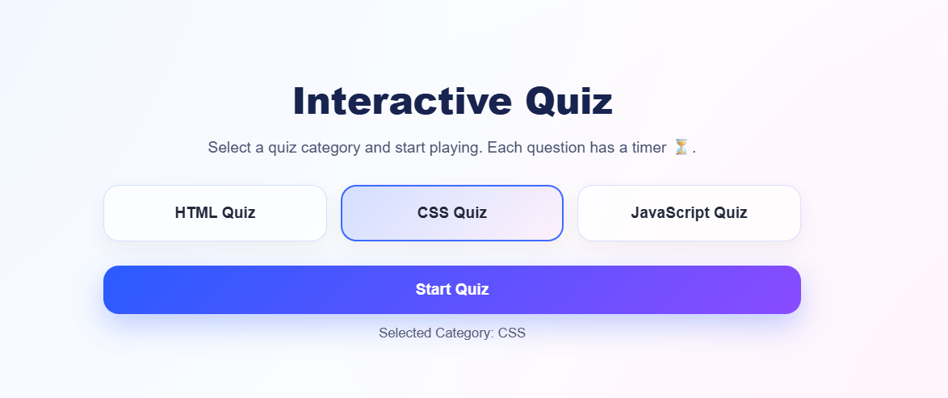
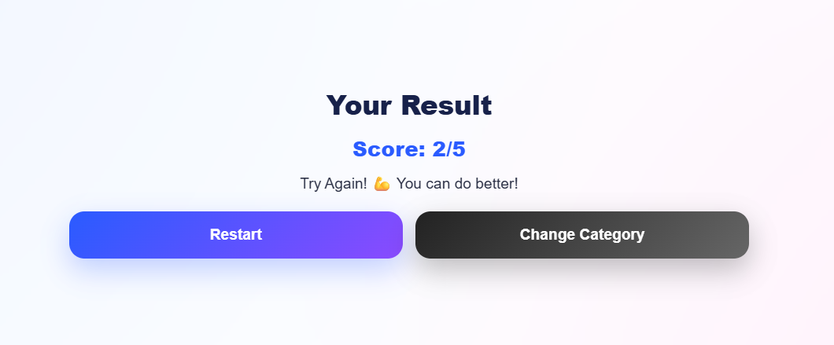
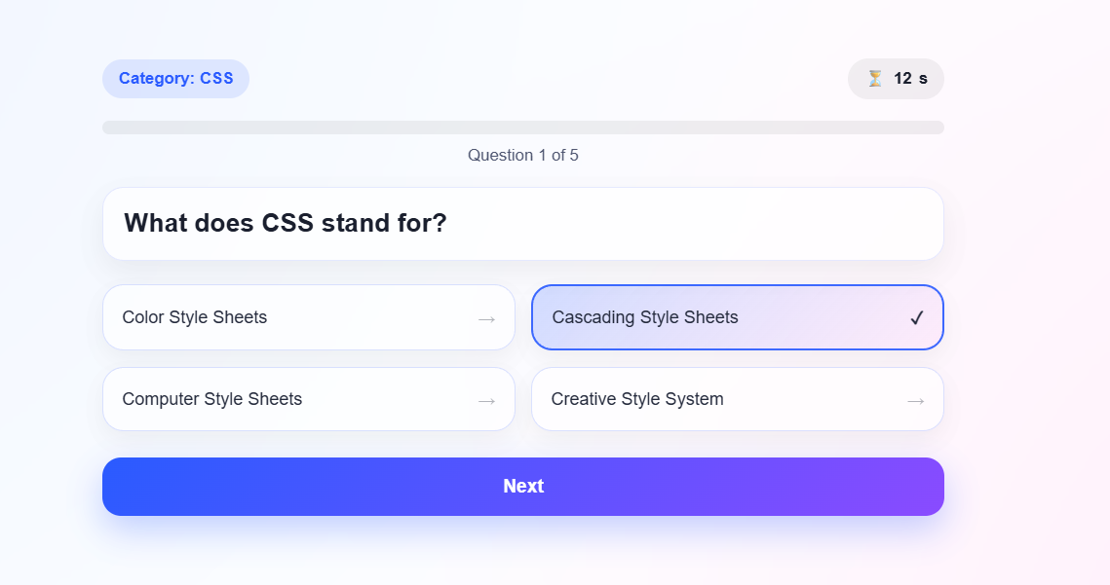

Output:
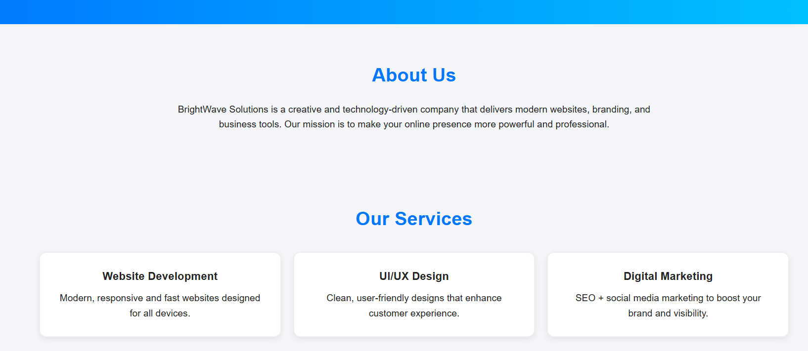

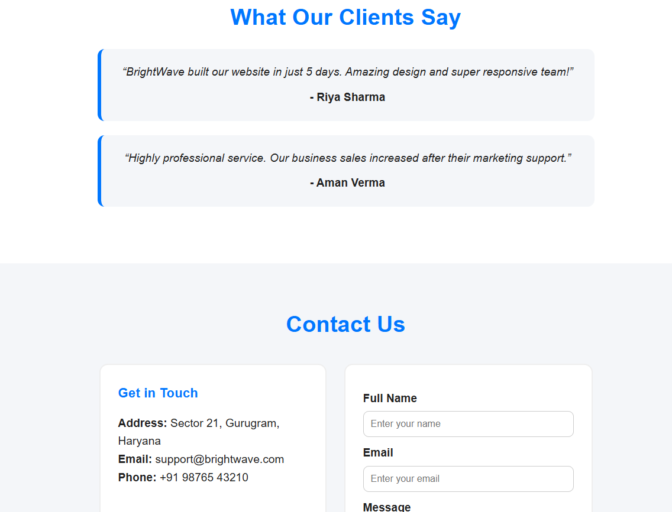

Output:
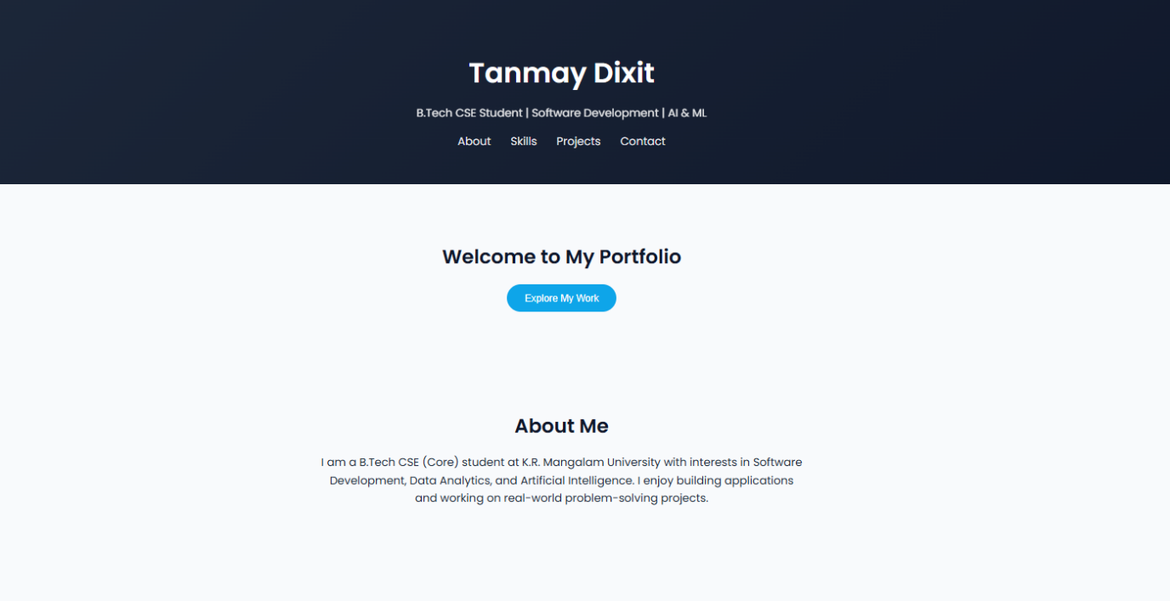
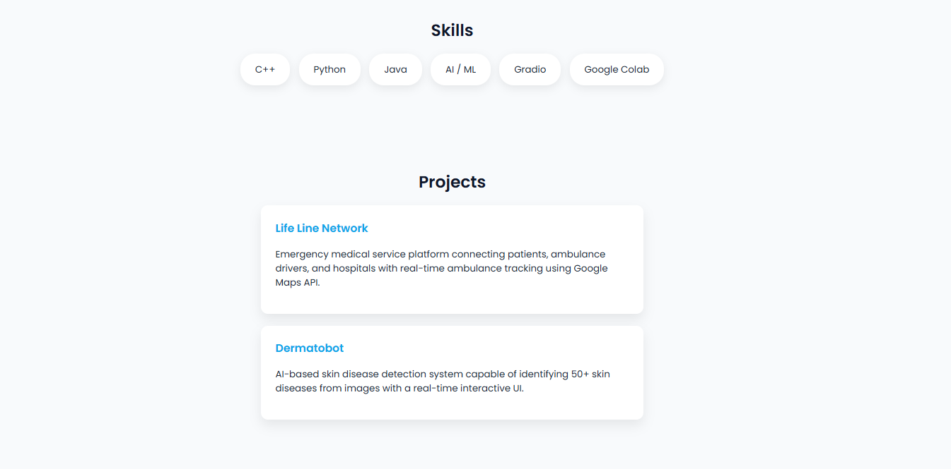
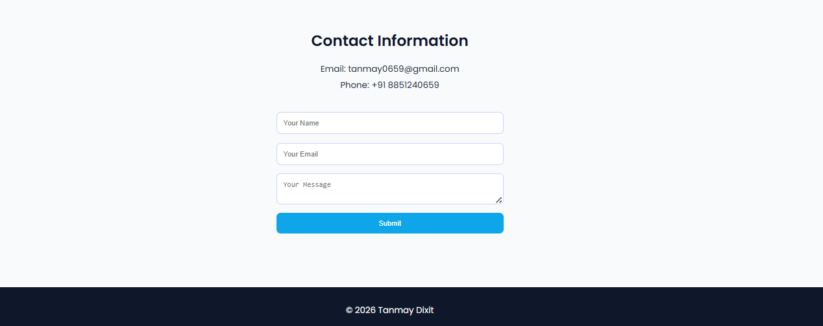

Output:
